Step1: Place the chromedriver.exe, Test.xlsx files and BSNL Retrieve report data to Excel runnable Jar file at C:\Users\Public location

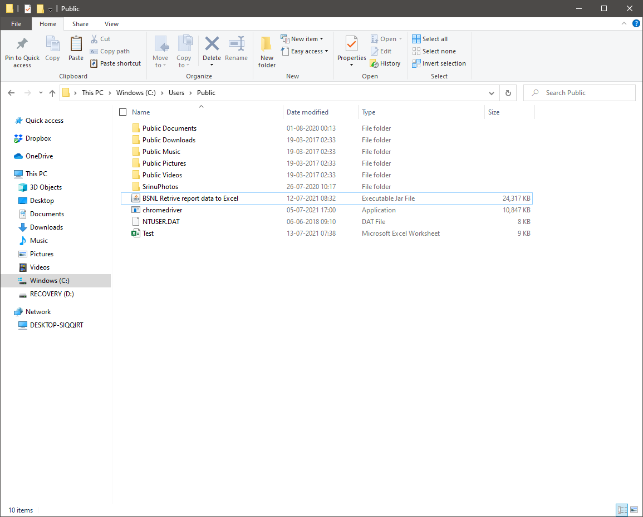

Step 2: Double Click on BSNL Retrive report data to Excel runnable Jar file 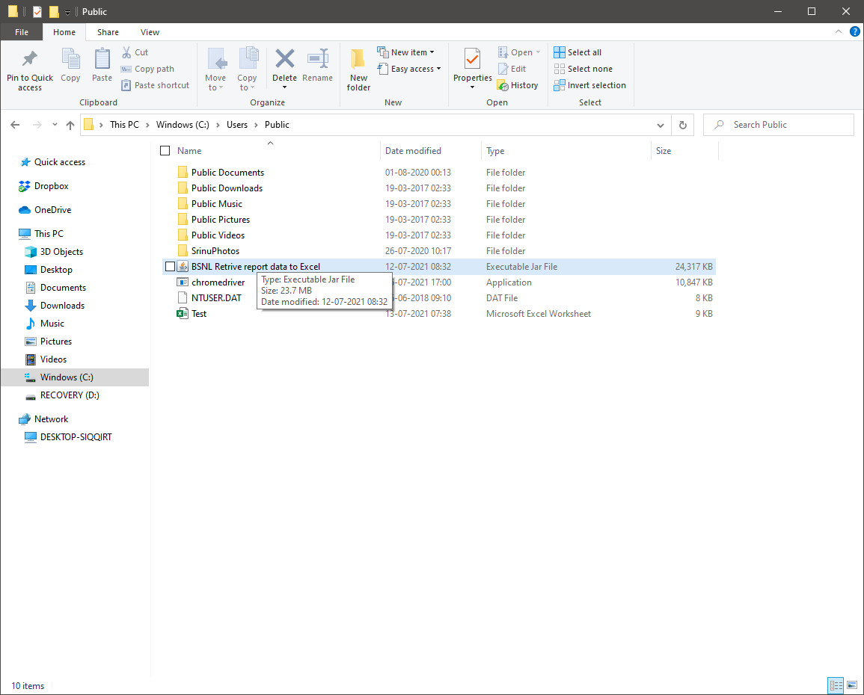

Step 3: Script has opened a browser and navigate to the URL (Automation)

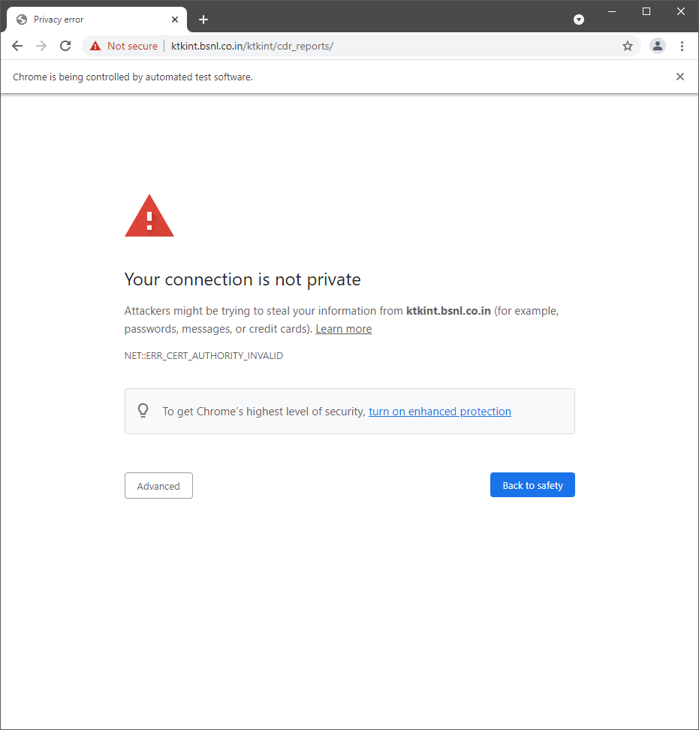

Step 4: Click on Advanced (Manual)

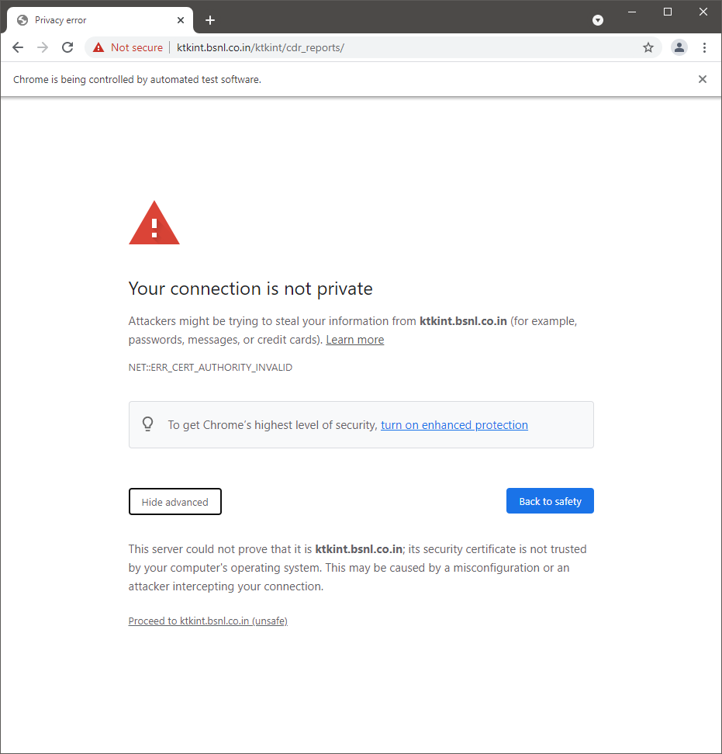

Step 5: Click on Proceed to Ktkint.bsnl.co.in

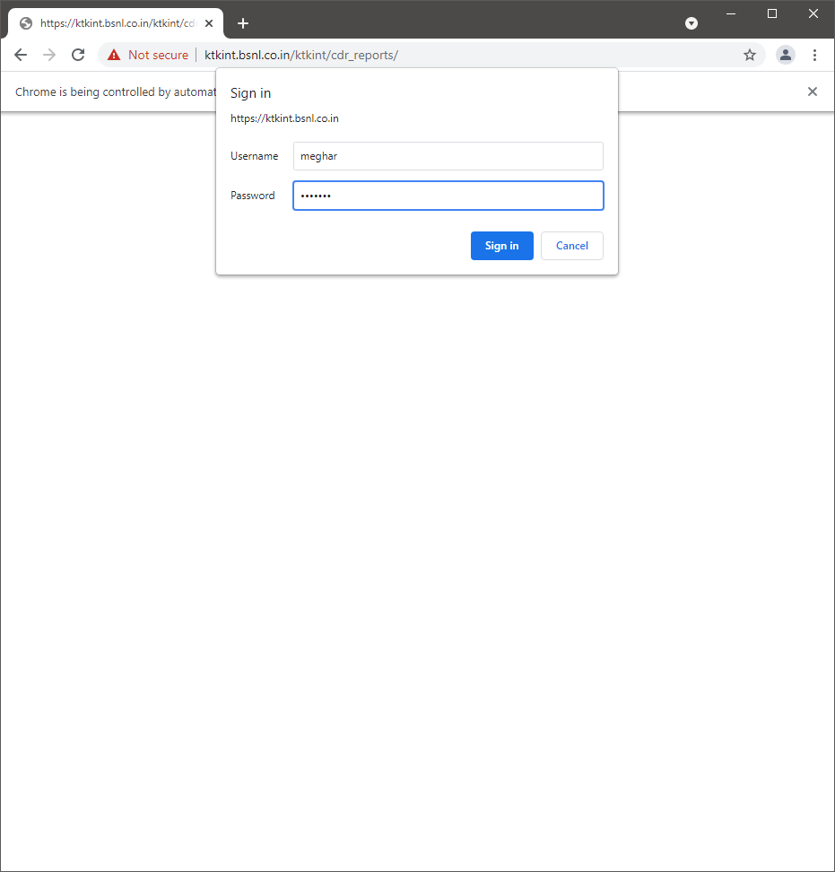

Step 6: Enter User name and Pwd and click on Sign on (Manual), then User Navigated to Reports Page

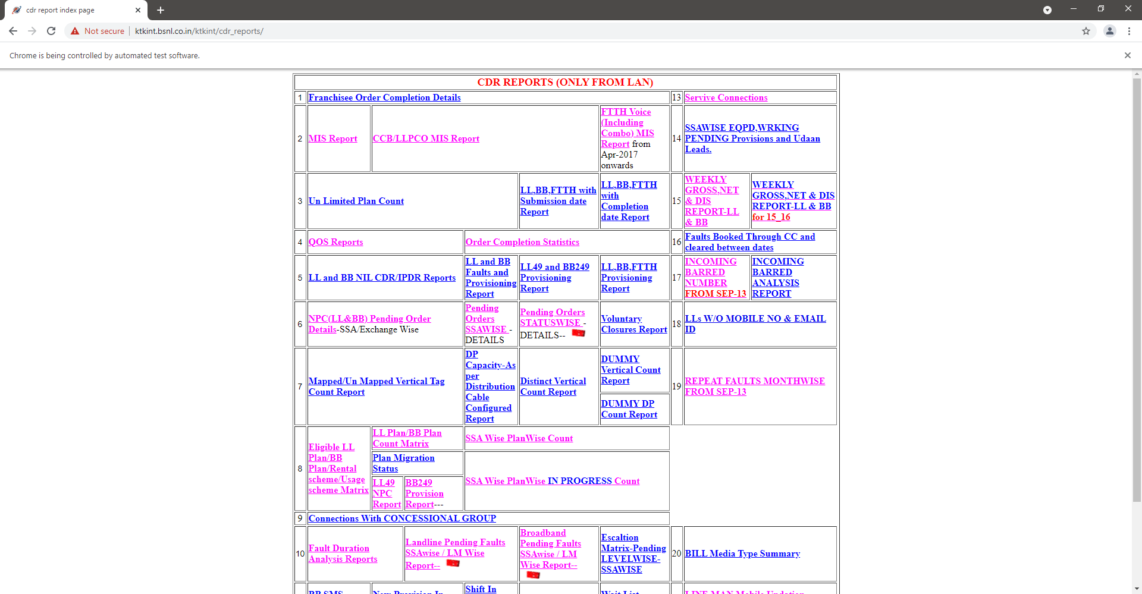

Step 7: Scripts has clicked on MIS Report (Automation)

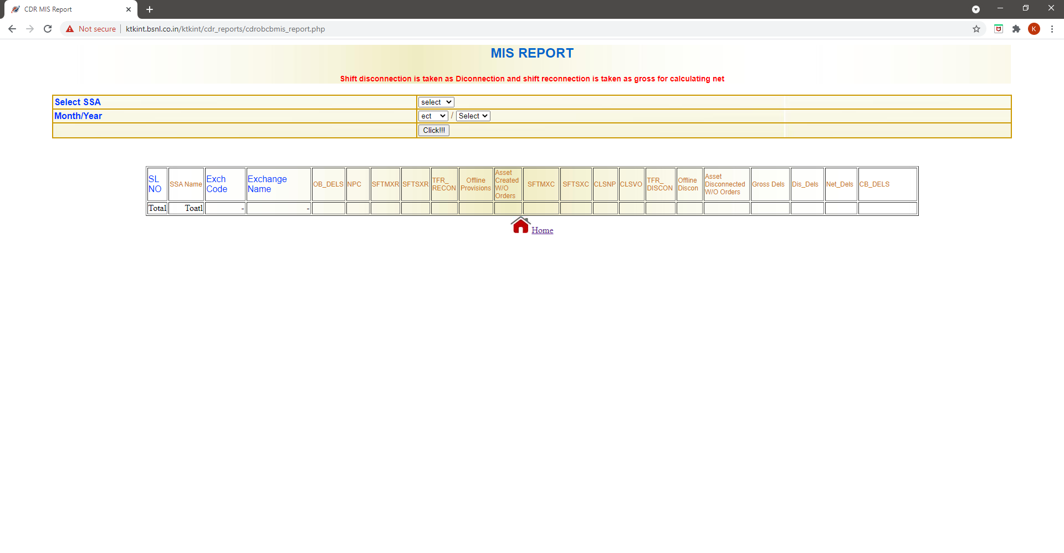

Step 8: Select required fields from drop down and click!!! Then Report data is displayed (Automation)

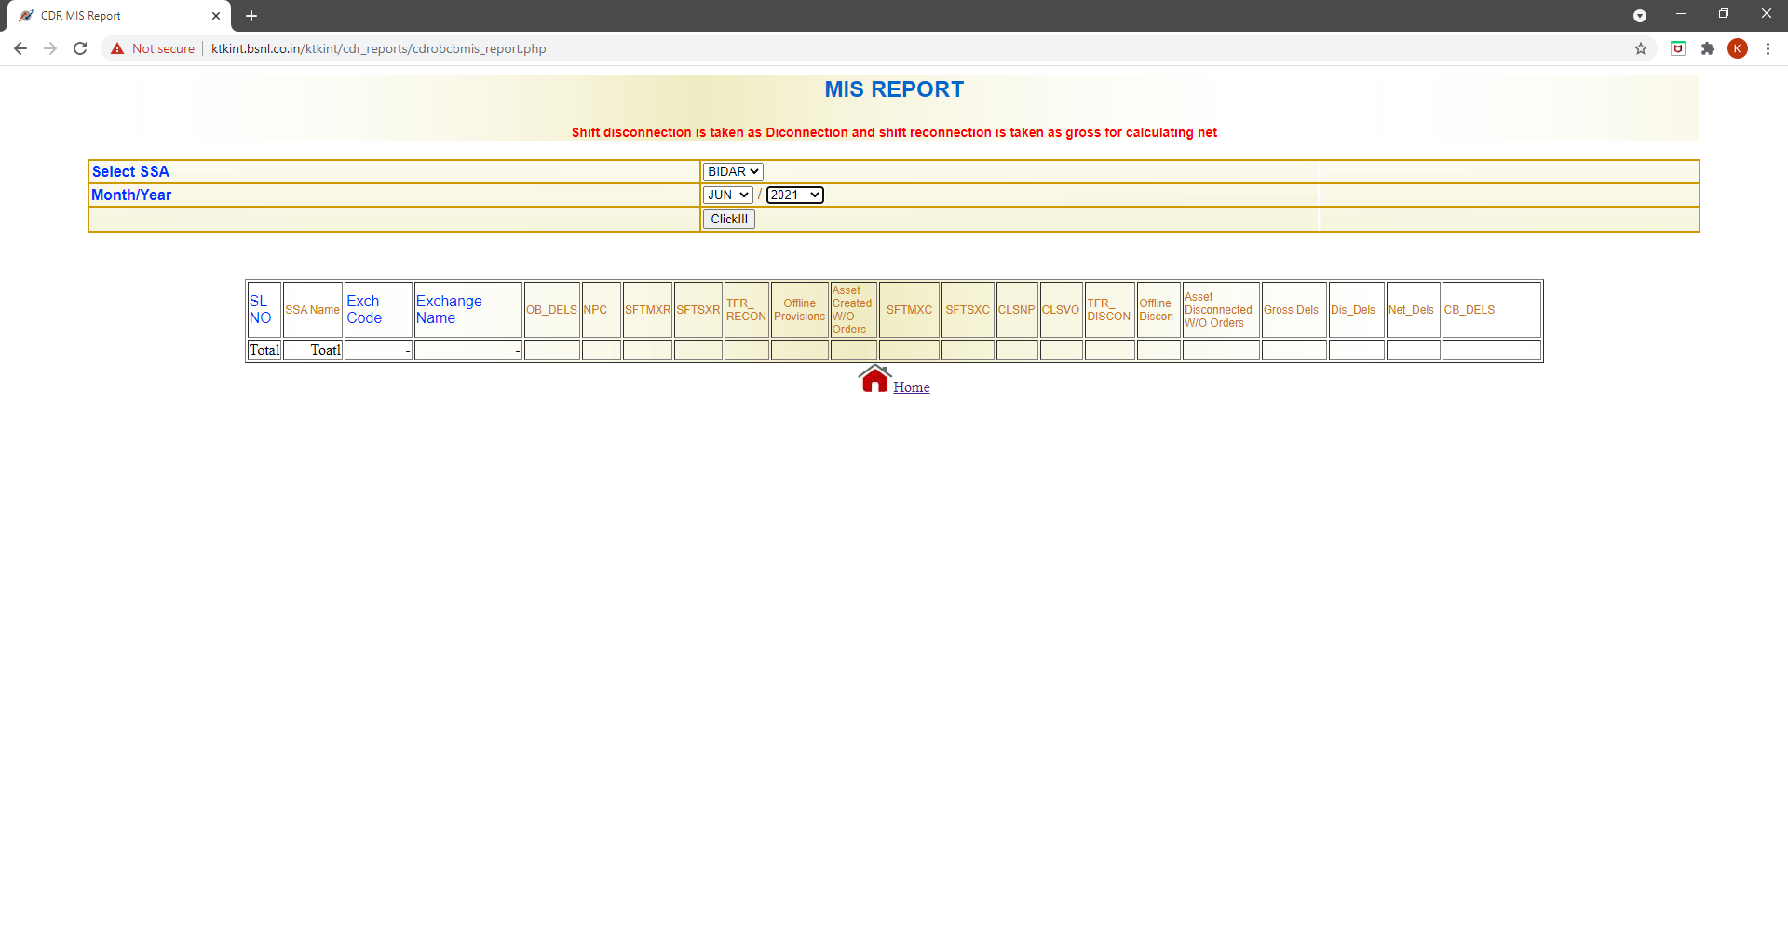

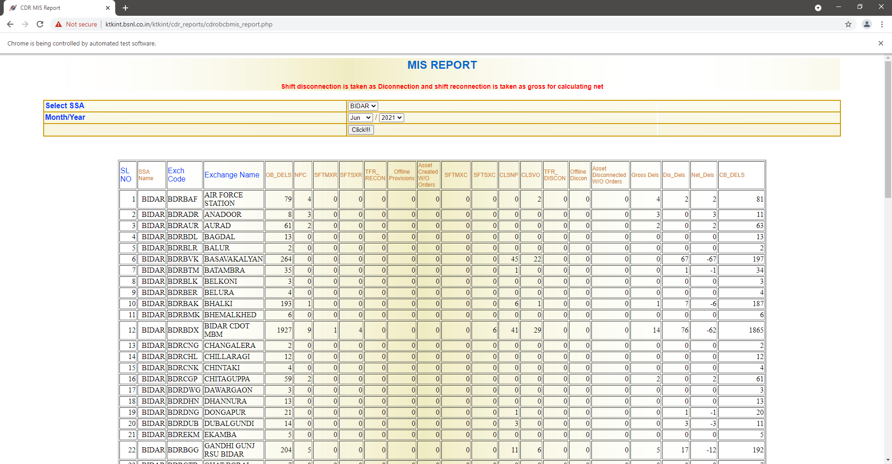

Step 9: Script has retrieving the data from report and saving into Test.xlsx file (Automation)

Wait for 3 to 4 mins, wait until above gets closed

Step 10: Navigate to C:\Users\Public location and Open the Test.xlsx file and Verify the report data (Manual)

